**Lab#8**

**Aim : Using PHP Regex,**

**a. Implementing Registration Form Validation using Regular Expressions.**

**Final Outcome:**

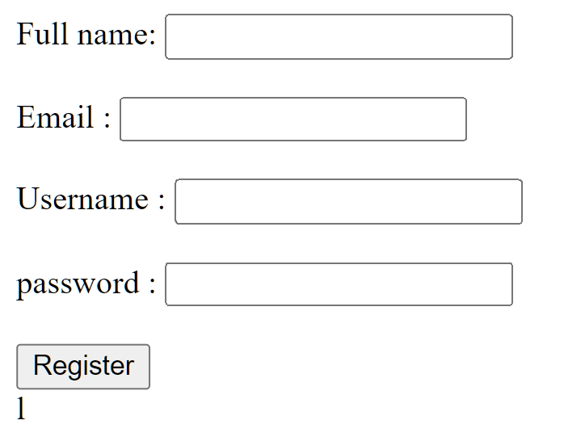

**Code Snippet:**

**Frontend code**

<!DOCTYPE html>

<html lang="en">

<body>

<form action="lab8_back.php">

Full name: <input type="text" name="fullname"> <br> <br>

Email : <input type="email" name="email"><br> <br>

Username : <input type="text" name="username" id=""> <br> <br>

password : <input type="password" name="password" id=""> <br> <br>

<input type="submit" value="Register"> <br>

</form>

</body>

</html>

**Backend Code:**

<?php

if($_POST)

{

$name = $_POST['name'];

$email = $_POST['email'];

$username = $_POST['username'];

$password = $_POST['password'];

// Full Name

if (eregi('^[A-Za-z0-9 ]{3,20}$',$name)) {

$valid_name=$name;

}

Else {

$error_name='Enter valid Name.';

}

// Email

if (eregi('^[a-zA-Z0-9._-]+@[a-zA-Z0-9._-]+\.([a-zA-Z]{2,4})$', $email)){

$valid_email=$email;

} else {

$error_email='Enter valid Email.';

}

// Usename min 2 char max 20 char

if (eregi('^[A-Za-z0-9_]{3,20}$',$username)) {

$valid_username=$username;

} else {

$error_username='Enter valid Username min 3 Chars.';

}

// Password min 6 char max 20 char

if (eregi('^[A-Za-z0-9!@#$%^&*()_]{6,20}$',$password)) {

$valid_password=$password;

} else{

$error_password='Enter valid Password min 6 Chars.';1

}

?>